

**Golden-Gate Int’l College**

Affiliated to Tribhuvan University

Old Baneswor, Kathmandu

**A**

**Lab Report on**

**Mobile Programming**

**(CACS 351)**

**Lab Title: Android Programming: Activities & Fragments**

**Lab Sheet No: 1**

|  |  |
| --- | --- |
| **Submitted by:** | **Submitted to:** |
| Name: Surakshya Lama | Mr. Deepak Thakur |
| Roll no:15 | Submission date: 2nd April, 2025 |
| Registration no:6-2-453-15-2021 |  |

**Task 1.1:**

**Design Book Entry interface.**

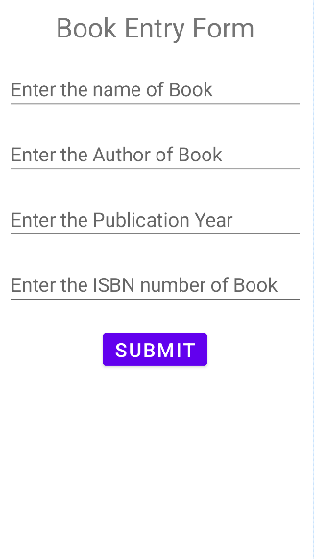

**Task 1.2:**

**Calculate Simple Interest and Display the Result in Same Activity.**

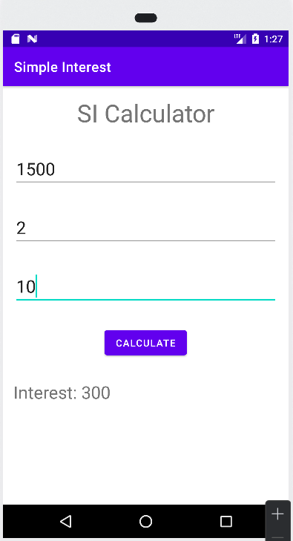

**Task 1.3:**

**Design Employee Entry Form insert the data and show to another activity.**

|  |  |
| --- | --- |
| Entry Screen: | Display Screen: |

**Task 1.4:**

**Implement Three Fragment in one Activity.**

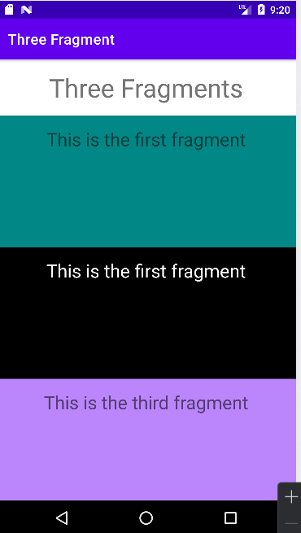

**Task 1.5:**

**Transfer data from one fragment to another Fragment.**

|  |  |
| --- | --- |
| Entry Screen: | Display Screen: |